**Assignment 3**

**Name- Tanishq Umesh Walzade**

1. What was your hardening index score?

Hardening Index Score: 53

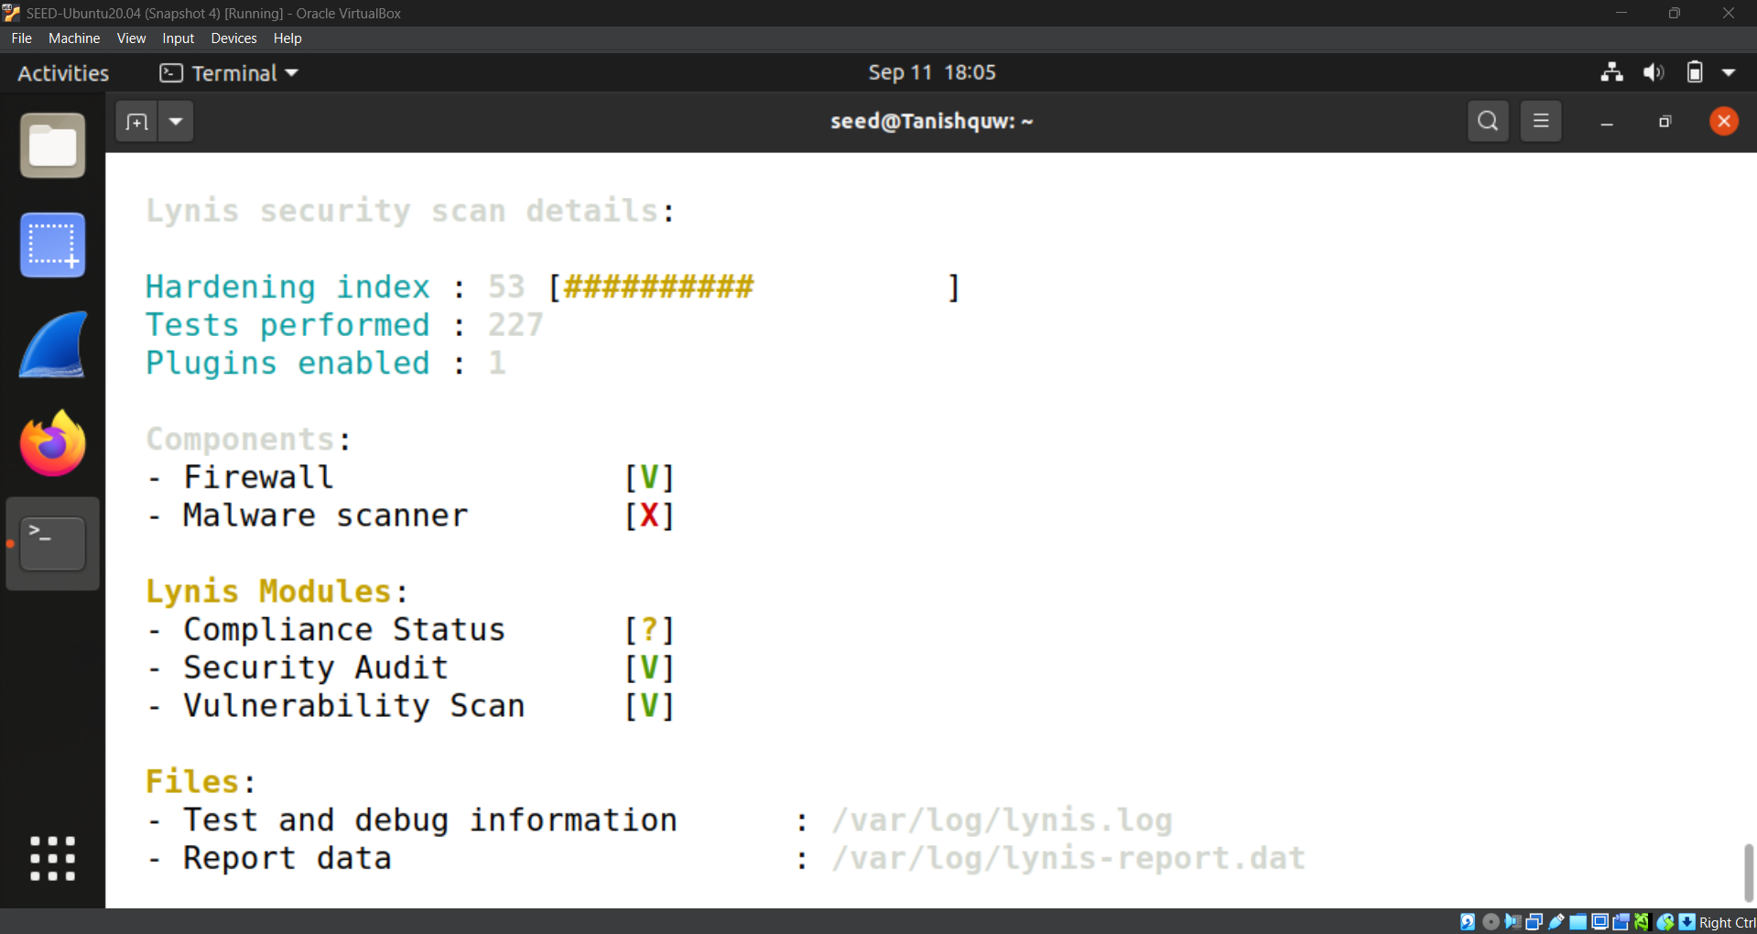

2. List at least 2 warnings Lynis flagged.

1. Program update status



1. Checking for password protection



1. List at least 2 suggestions for improving security.
   1. PAM password strength tools



* 1. Checking mount points (/home, /tmp, /var)

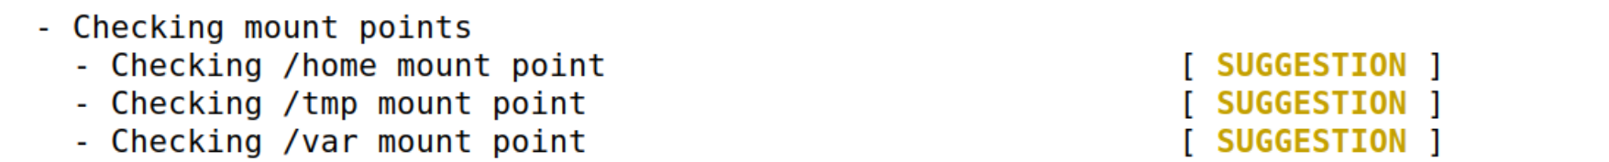

1. In your own words: Why is auditing important before putting a server into production?

Auditing is important before putting a server into production because it lets you check the system for mistakes or weak spots before it goes live. It helps find problems like weak passwords, open services, or wrong settings so you can fix them early. This makes the server safer, more reliable, and ready to handle real users without unexpected issues.